**SCREENSHOTS:**

**CREATED A SIMPLE PIPELINE FIRST:**

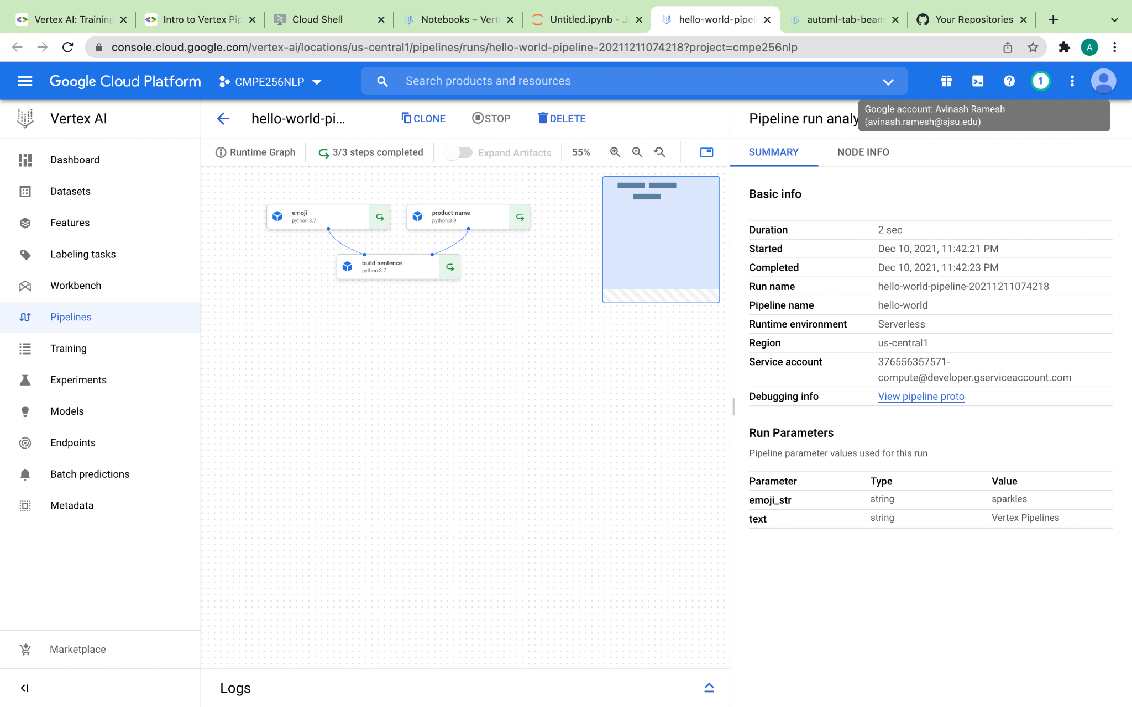

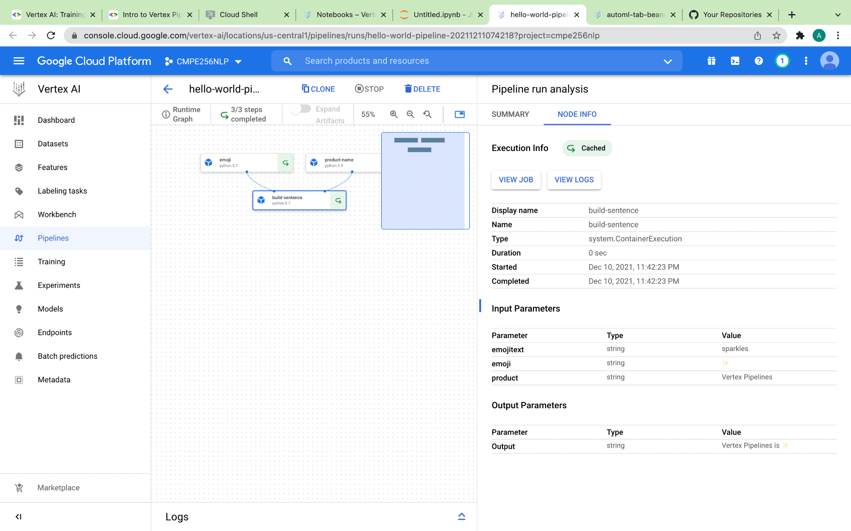

**CREATED AN END-TO-END PIPELINE:**

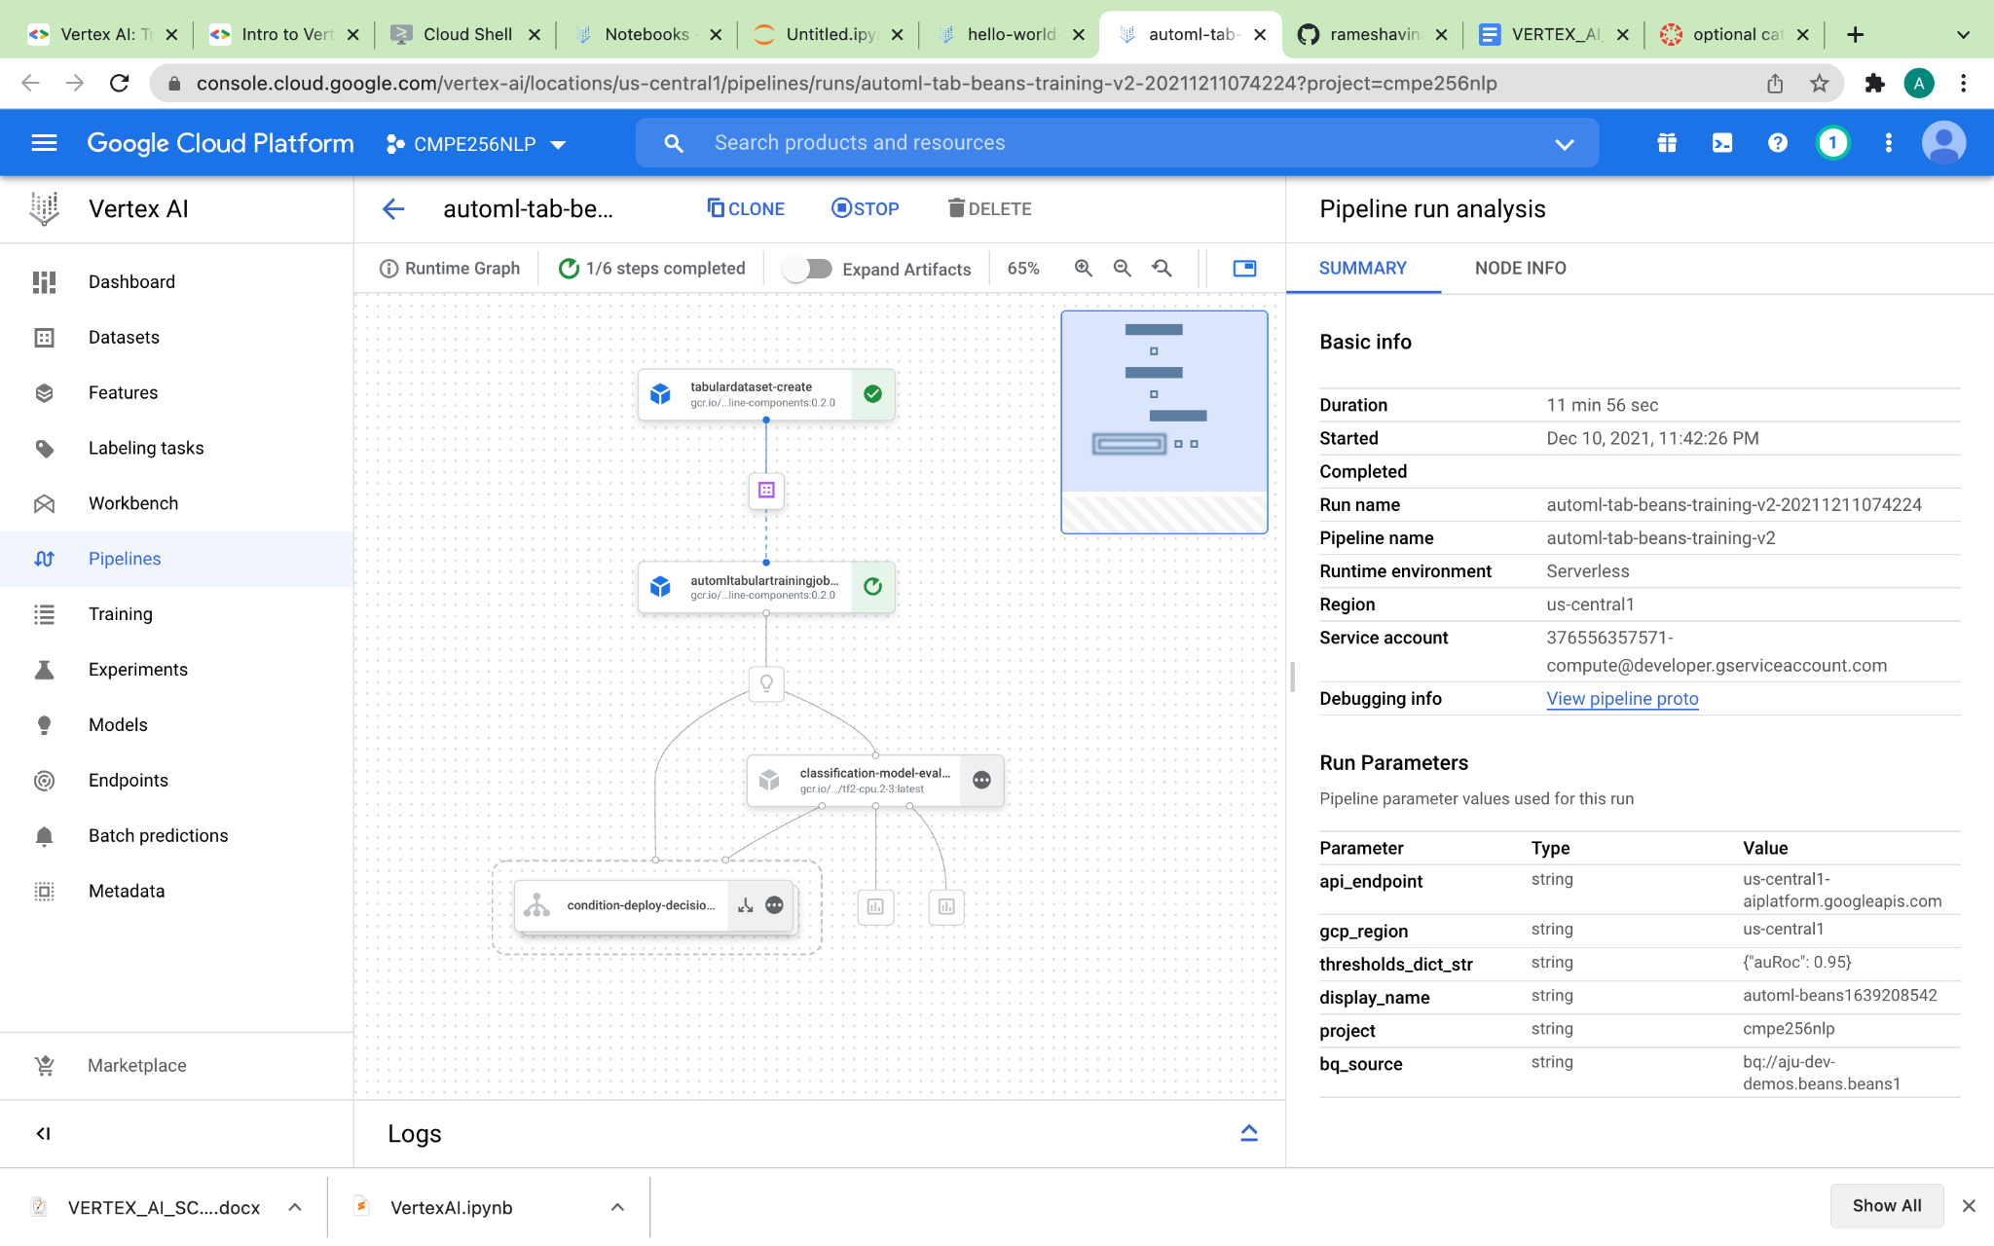

**EXPANDED ARTIFACTS:**

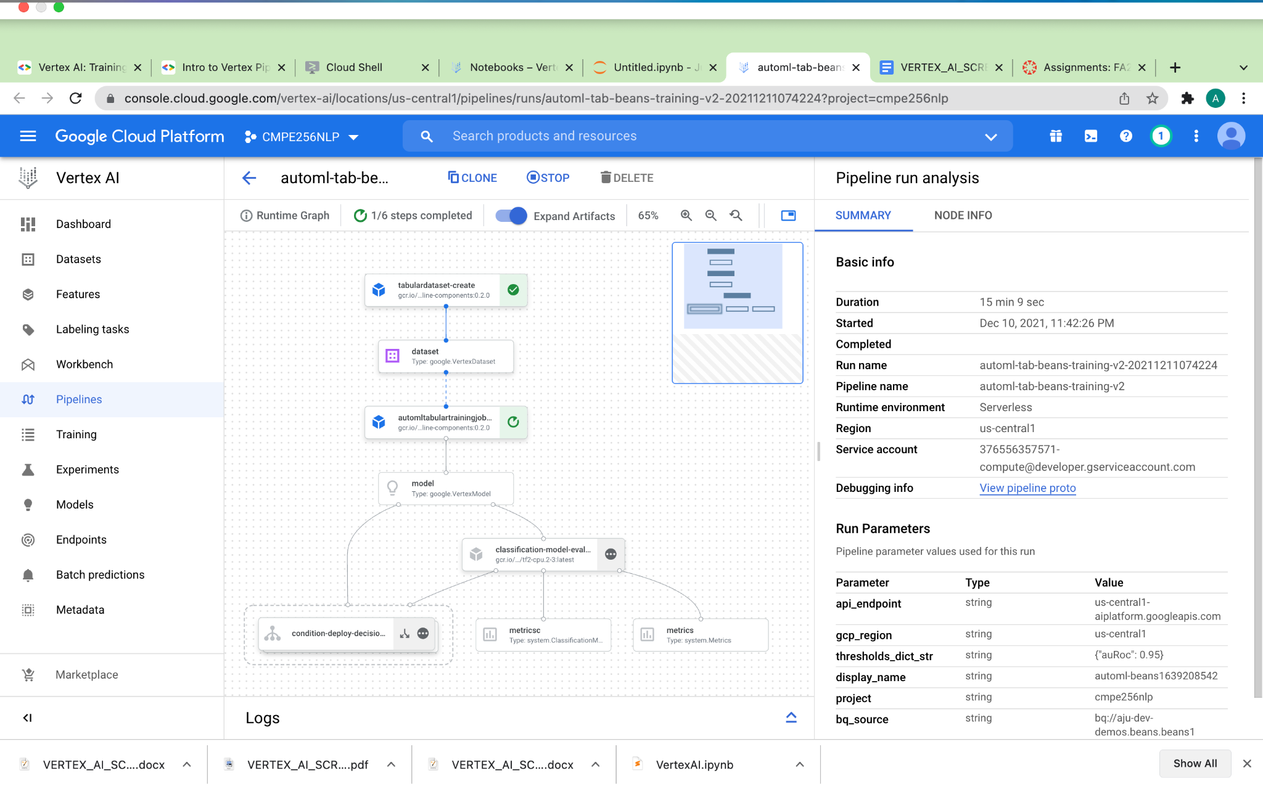

**COMPLETE ALL STEPS**

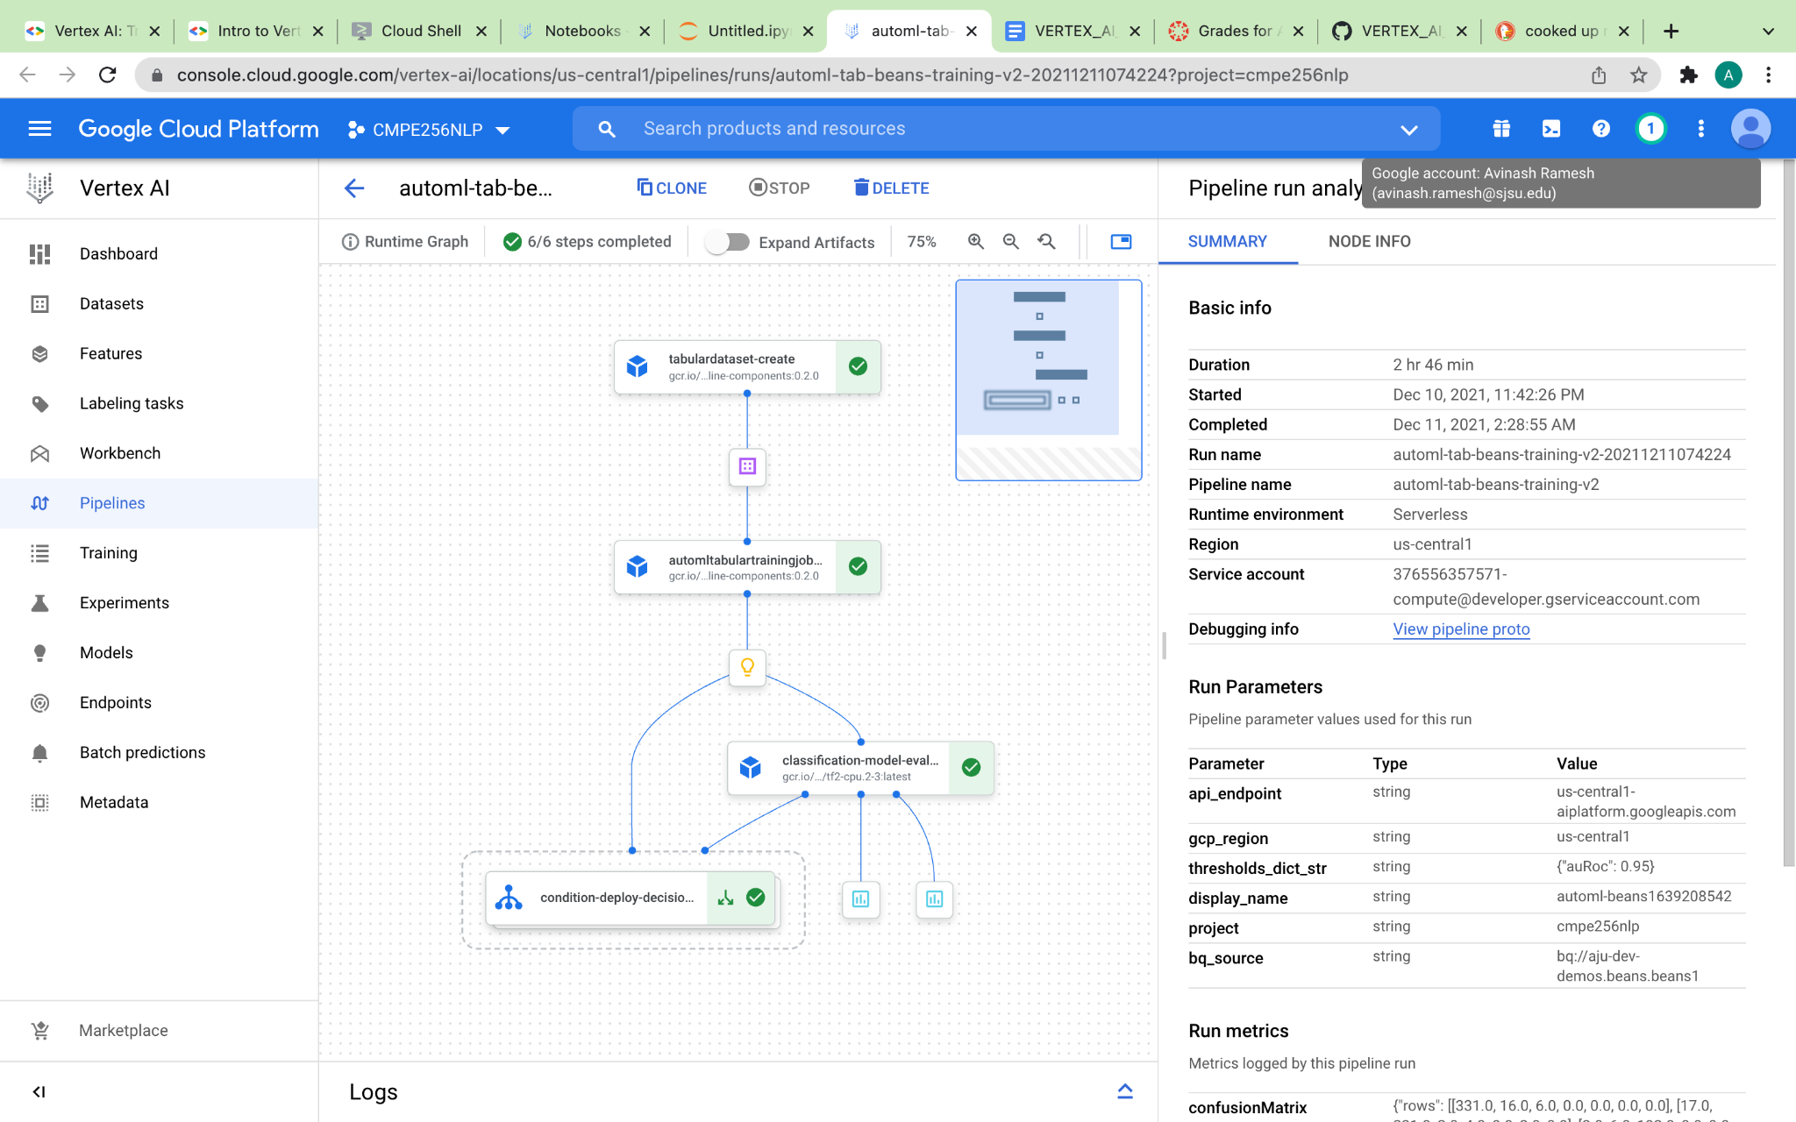

**METRICS:**

